

Project Final Report

Only for course Teacher
 |  | Needs Improvement | Developing | Sufficient | Above Average | Total Mark
Allocate mark & Percentage |  | 25% | 50% | 75% | 100% | 25
Understanding | 3
Analysis | 4
Implementation | 8
Report Writing | 10
Total obtained mark
Comments

Semester: Summer-2025

Student Name: Mst. Sirazam Monira (242-35-637)
Rakib Hasan Piyas (242-35-182)
Tareq Ahmed (242-35-580)
Tahamid Islam Zihad (242-35-435)
Atikur Rahman (242-35-632)

Batch: 43 Section: F1
Course Code: SE 133
Course Name: Software Development Capstone project

Course Teacher: Durjoy Bhowmik
Designation: Lecturer
Department of Software Engineering (SWE)
Daffodil International University

Submission Date: 17-08-2025
Table of Contents

Introduction
Objective------------------------------------------------------------------------------------------------------03
Key Features -------------------------------------------------------------------------------------------------03
Scenario Writing
Scenario-1: Viewing Department List--------------------------------------------------------------------04
Scenario-2: Checking Total Tuition Fee------------------------------------------------------------------04
Scenario-3: Verifying Admission Eligibility-------------------------------------------------------------04
Scenario-4: Knowing Semester System------------------------------------------------------------------04
Scenario-5: Finding Hall and Seat Info-------------------------------------------------------------------04
Scenario-6: Checking Available Waivers----------------------------------------------------------------05
Stakeholders User Profile
User Profile-01: Prospective Student---------------------------------------------------------------------05
User Profile-02: Admin-------------------------------------------------------------------------------------06
User Profile-03: Current Student--------------------------------------------------------------------------06
Scope
1.User Registration and Login-----------------------------------------------------------------------------07
2. Add and Update Profile----------------------------------------------------------------------------------07
3. View and Access Academic Resources----------------------------------------------------------------08
4. Notices and Announcements----------------------------------------------------------------------------08
5. Make Complaint/ Feedback/ Helpdesk----------------------------------------------------------------08
6. Notification System--------------------------------------------------------------------------------------08
7. Helpline and Support-------------------------------------------------------------------------------------09
8. Security Measures----------------------------------------------------------------------------------------09
Feasibility Study
- Technical Feasibility----------------------------------------------------------------------------------10
- Economic Feasibility----------------------------------------------------------------------------------10
- Operational Feasibility--------------------------------------------------------------------------------11
- Schedule Feasibility-----------------------------------------------------------------------------------11
Software Requirement Specification (SRS)---------------------------------------------------------------11
Use Case Diagram------------------------------------------------------------------------------------------15
User Case Description-------------------------------------------------------------------------------------16
Case Description-01: Registration------------------------------------------------------------- 16
Case Description-02: Login---------------------------------------------------------------------16
Case Description-03: View Department Info-------------------------------------------------17
Case Description-04: View Total Seat per Department-------------------------------------17
Case Description-05: View Waiver------------------------------------------------------------18
Case Description-06: Check Direct Admission Eligibility--------------------------------- 18
Case Description-07: View Admission Test Info--------------------------------------------19
Case Description-08: View Hall Information-------------------------------------------------19
Case Description-09: Receive Notifications --------------------------------------------------20
Case Description-10: Use App Offline--------------------------------------------------------20
Case Description-11: Maintain Data-----------------------------------------------------------20
Case Description-12: Help And Support------------------------------------------------------21
Activity Diagram
Admin & User-------------------------------------------------------------------------------------22

Class Diagram---------------------------------------------------------------------------------------------------23
Programming Language & Features Used
Conditional Statements------------------------------------------------------------------------24
Loops---------------------------------------------------------------------------------------------24
Functions----------------------------------------------------------------------------------------24
String Handling--------------------------------------------------------------------------------24
Structures----------------------------------------------------------------------------------------24
Console I/O-------------------------------------------------------------------------------------25
Project Plan
Phase 1-------------------------------------------------------------------------------------------25
Phase 2-------------------------------------------------------------------------------------------25
Phase 3-------------------------------------------------------------------------------------------25
Phase 4-------------------------------------------------------------------------------------------25
Phase 5-------------------------------------------------------------------------------------------25
Resources----------------------------------------------------------------------------------------25
Budget
The Estimated Project Budget-----------------------------------------------------------------26
Funding Source----------------------------------------------------------------------------------26
Evaluation
Criteria-------------------------------------------------------------------------------------------26
Methods -----------------------------------------------------------------------------------------26
Conclusion------------------------------------------------------------------------------------------------26
User Manual
- Start------------------------------------------------------------------------------------------27
- User Registration---------------------------------------------------------------------------28
- Login-----------------------------------------------------------------------------------------28
- Admin Mood--------------------------------------------------------------------------------28
- User Panel-----------------------------------------------------------------------------------28
- Department Information-------------------------------------------------------------------29
- Total Seat------------------------------------------------------------------------------------29
- Waiver---------------------------------------------------------------------------------------30
- Direct Admission---------------------------------------------------------------------------31
- Admission Test Information--------------------------------------------------------------31
- Hall information----------------------------------------------------------------------------32
- Help & Support-----------------------------------------------------------------------------33
- Admin Mood--------------------------------------------------------------------------------33
- Registered User-----------------------------------------------------------------------------33
- User Data------------------------------------------------------------------------------------34
- Update Data---------------------------------------------------------------------------------34
- Delete Data----------------------------------------------------------------------------------34
- Update Data---------------------------------------------------------------------------------35
- Logout---------------------------------------------------------------------------------------35
- About this App-----------------------------------------------------------------------------36
- Exit------------------------------------------------------------------------------------------36

Introduction

DIU Info Corner is an app that helps students (especially new ones) get all the important information about Daffodil International University in one place. It gives clear details about all departments, tuition fees, seat numbers, admission rules, waiver options, and hall facilities.
Many students face problems while searching for this kind of info, especially during admission time. This app is made to solve that issue and make everything simple and easy to find.

Objective

- To make an app that shows all the main information about DIU in one place.
- To help students understand which departments are available and what the total costs are.
- To show admission eligibility rules clearly so students know if they need to take an admission test or not.
- To provide information about student halls and how many seats are there.
- To make it easier for students to plan their studies and admissions without confusion.

Key Features

• Department List
- Shows all the departments in DIU.

• Total Tuition Fee (per department)
- Gives the full tuition fee for each department (before/after waiver if applicable).

• Total Seat per Department
- Shows how many seats are available in each department.

• Semester Status (Bi/Tri)
- Tells if the department follows a bi-semester (2 semesters in a year) or tri-semester (3 semesters in a year) system.

• Waiver List
- Shows available waivers like merit-based, sibling, or financial need, and how much percentage is given.

• Admission Eligibility
- Shows who can get direct admission and who needs to take an admission test.
Example: If someone has less than GPA 5.00 in both SSC and HSC, they have to take the test.

• Hall & Seat Information
- Lists the names of student halls and how many students each can accommodate.

Scenario Writing

Scenario 1: Viewing Department List
Scenario Description
A student wants to see which departments are available at DIU before choosing one for admission.
Steps:
- The user opens the DIU Info Corner app.
- They tap on the “Department List” option.
- The app shows a list of all departments grouped by faculty.
- The user browses through the departments and selects one to explore more.

Scenario 2: Checking Total Tuition Fee
Scenario Description
A student wants to know how much the total tuition fee is for a specific department.
Steps:
- The user opens the app.
- They tap on the “Tuition Fee” section.
- The user selects the desired department (e.g., CSE).
- The app shows the full tuition fee with and without waivers.

Scenario 3: Verifying Admission Eligibility
Scenario Description
A student is unsure whether they need to take an admission test based on their SSC & HSC GPA.
Steps:
- The user opens the app.
- They go to the “Admission Eligibility” section.
- They input their SSC and HSC GPA.
- The app calculates and shows whether they are eligible for direct admission or need to take an admission test.

Scenario 4: Knowing Semester System
Scenario Description
A student wants to know if their chosen department follows a bi-semester or tri-semester system.
Steps:
- The user opens the app.
- They select the “Semester Status” option.
- They choose their department from the list.
- The app shows whether it follows bi-semester or tri-semester.

Scenario 5: Finding Hall and Seat Info
Scenario Description
A student coming from outside Dhaka wants to know about hostel options and seat availability.
Steps:
- The user opens the app.
- They go to the “Hall Info” section.
- They see a list of halls (boys/girls) and total available seats.
- They note the details to plan for staying at the university hall.
Scenario 6: Checking Available Waivers
Scenario Description
A student with a good GPA wants to know which waivers they can get.
Steps:
- The user opens the app.
- They click on the “Waiver List” section.
- The app displays different waiver categories (Merit, Sibling, Financial, etc.).
- The student checks which one matches their condition and sees the percentage.

Stakeholder

The key Stakeholders involved in this DIU Info Corner are:

Admin: Manages and updates department, fee, and admission data in the app.
Student (Prospective): Uses the app to check departments, tuition, waivers, and admission eligibility.
Student (Current): May use the app for quick reference or to help others with admission info.
App Developer: Builds and maintains the app features and user interface.
University Authority: Provides official data and gives approval for app use.

User Profile

User Profile-01: Prospective Student

User Class | Notes on Characteristics | Requirements Implied
Type of user | End user | Needs user-friendly interface
Age range | 17–22 | Design should be modern, youthful, and visually clear
Frequency of use | Occasionally (mainly during admission time) | Fast access to information; quick loading time
Mandatory | No | Should be engaging and useful to encourage voluntary usage
Computer experience | Basic to Moderate | Simple navigation and interface
Education | HSC pass | Content should be understandable without complex terms
Goals | Check eligibility, fees, seat availability | Information should be well-organized and easy to find
Language skills | Bengali/English (basic level) | Use clear, simple English (or Bengali if localized)
Number of users | High (thousands of applicants each intake) | App must handle multiple users smoothly
Training | None | Intuitive UI that doesn’t require any guidance
Other systems used | Website, social media, YouTube | Should sync or align with other platforms used by DIU
Ways of working | Mobile-first, short attention span | Should be optimized for mobile use with short, precise content

User Profile-02: Admin

User Class | Notes on Characteristics | Requirements Implied
Type of user | Back-end user, data updater | Needs admin dashboard
Age range | 25–40 | Professional-looking interface
Frequency of use | Weekly or as needed | Reliable and error-free data entry system
Mandatory | Yes | Access control and authentication required
Computer experience | Moderate to High | Can handle technical tools
Education | Bachelor's degree or higher | Can manage structured data
Goals | Update tuition fees, seat data, eligibility rules | Admin panel with data forms and validation
Language skills | Fluent in English | Interface can include technical terms
Number of users | Few (1–5 admins) | Role-based access control is important
Training | Minimal | Simple admin instructions or onboarding required
Other systems used | University database, Excel | Should support data import/export options
Ways of working | Office hours, desktop usage | Desktop-friendly admin panel interface

User Profile-03: Current Student

User Class | Notes on Characteristics | Requirements Implied
Type of user | Occasional viewer | Must offer updated, accurate info
Age range | 18–25 | Youth-friendly design
Frequency of use | Low | App should work without login
Mandatory | No | Optional access — should be helpful
Computer experience | Moderate | Can navigate normal UI
Education | Undergraduate | Clear academic information presentation
Goals | Sharing info, checking halls or semester status | Must have quick search and clear department data
Language skills | Moderate | Use readable English
Number of users | Moderate | Scalable system to support light usage
Training | None | Should be self-explanatory
Other systems used | Student Portal, Facebook groups | Can be linked or promoted via other student systems
Ways of working | Mobile-first, casual | Should be mobile-optimized

Project Scope for DIU Info Corner App

The DIU Info Corner application is designed to serve as a centralized platform for Daffodil International University students to access academic resources, campus news, departmental updates, and essential services. It aims to simplify communication and access to important information, enhancing the overall student experience.
The system will include the following features:

1. User Registration and Login

- Description:
This functionality allows users (students, teachers, staff) to create and access accounts securely.
- Sign-up Process: Users register with their student email ID and a password. Optional: Google or university SSO login integration.
- Login Functionality: Login using email & password. Include options for password reset and 2FA (two-factor authentication).
- Account Management: Users can update their profile, reset passwords, and manage personal preferences.

2. Add and Update Profile

- Description:
Users can manage their personal profiles for a customized experience.
- Create Profile: Add details like name, ID, department, semester, blood group, etc.
- Additional Information: Optional fields such as phone number, address, social links (e.g., LinkedIn).
- Edit/Delete Info: Users can modify or remove profile details as needed.

3. View and Access Academic Resources

- Description:
Provides quick access to academic materials and tools.
- Class Routine: Students can view and download their updated class routine.
- Exam Schedule: View upcoming exam dates, hall plans, and seat arrangements.
- Results: Link to official result portals or notifications.
- Course Materials: Optional feature for accessing shared PDFs, lecture notes (by teachers or CRs).

4. Notices and Announcements

- Description:
Centralized noticeboard for all university updates.
- General Notices: Campus-wide announcements.
- Departmental Notices: Segmented updates for each department or faculty.
- Search & Filter: Filter by category, date, or keywords.

5. Make Complaint / Feedback / Helpdesk

- Description:
Students can raise issues or provide suggestions.
- Submit Complaint: Category-based complaint system (Academic, WiFi, Hostel, Cleanliness, etc.).
- Track Status: Students can see the progress or solution status.
- Anonymous Mode: Optional anonymous feedback.

6. Notification System

- Description:
Keeps users updated with real-time push notifications.
- Custom Notifications: Based on routine changes, new notices, upcoming exams.
- Reminder Alerts: For events, fee payment deadlines, etc.
- User Control: Students can toggle which types of notifications to receive.

7. Helpline and Support

- Description:
Provides essential contact info and support options.
- Emergency Contacts: Transport, medical, admin office numbers.
- Live Chat or Bot: Optional in-app assistant or link to Messenger/WhatsApp support.
- FAQ Section: For quick answers to common queries.

8. Security Measures

- Description:
Ensures safety of user data and secure operation.
- HTTPS and Encryption: End-to-end encryption and SSL security.
- Data Privacy: Clear privacy policy regarding data use.
- User Verification: University email-based verification to avoid outsiders.

Feasibility Study
1. Technical Feasibility
  - Technology Used: Common web/mobile technologies (HTML, CSS, JavaScript, app builders)
  - Complexity: No advanced or costly tech needed; suitable for students or small teams
  - Hosting: University servers or affordable cloud services can be used
  - Development Time: Features are simple, so development time will be reasonable

2. Economic Feasibility
- Development Cost: Low, as free/open-source tools will be used
- Maintenance Cost: Minimal, requiring only regular updates from admins
- Benefits: Saves time and effort for students and university staff, increasing efficiency

3. Operational Feasibility
- User Needs: Meets needs of students and staff for easy access to information
- Usability: Simple and intuitive interface, no special training required
- Content Management: Admins can easily update and maintain current information

4. Schedule Feasibility
- Project Scope: Clear and limited to basic features
- Timeline: Can be completed within a university semester or project timeline
- Development Approach: Phased development and testing to ensure timely delivery

Software Requirement Specification

Project Title: DIU info Corner
Stakeholders: Students, Project Team, Supervisor

FR-01 | Registration
Description | The app must allow new users to register using their DIU university email or Phone Number for the guest and a secure password.
Stakeholders | Project Team, Students, Supervisor

FR-02 | Login
Description | The app should allow existing users to log in using their email or Phone number and password. The system must verify credentials and show relevant menus based on user type.
Stakeholders | Project Team, Students, Supervisor

FR-03 | Display Department Info
Description | The app should show a list of all departments in DIU with basic details like name, code, etc.
Stakeholders | Project Team, Students, Supervisor

FR-04 | Waiver Category Information
Description | The app must list all available waiver categories (based on result, sibling, freedom fighter etc.)
Stakeholders | Project Team, Students, Supervisor

FR-05 | Total Seat Per Dept
Description | Each department displays the total number of seats.
Stakeholders | Project Team, Students

FR-06 | Direct Admission Checker
Description | The app must allow users to check if they're eligible for direct admission based on SSC & HSC GPA.
Stakeholders | Project Team, Students

FR-07 | Admission Test Info
Description | If not eligible for direct admission, the app should inform the user about the admission test process.
Stakeholders | Project Team, Students

FR-08 | View Hall & Seat Information
Description | The app must display the list of student halls (male and female separately) along with the number of available seats in each hall.
Stakeholders | Project Team, Students

FR-09 | Offline Access Support
Description | Basic department and seat info should be available even without internet.
Stakeholders | Project Team, Students

FR-10 | Get Notifications
Description | Get notifications about application deadlines, admission test dates etc.
Stakeholders | Students

FR-11 | Maintain App & Update Data
Description | Update department info, seat numbers, waiver categories, application deadlines, admission test dates.
Stakeholders | Project Team, Supervisor

FR-12 | Help and Support
Description | The app should provide a “Help & Support” section that includes university emergency contacts, and an optional live chat or messaging link(WhatsApp) of Admins.
Stakeholders | Project Team, Supervisor

Use Case Diagram

Primary Actors: Students, Visitors, Guardians
Secondary Actors: Admin, Project Team
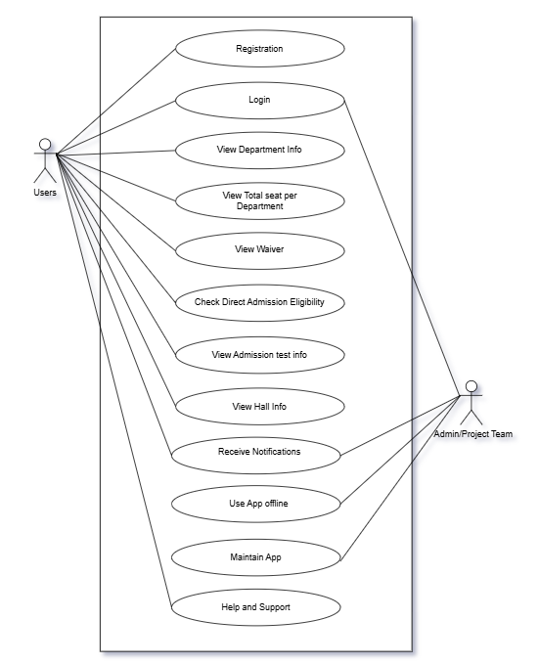

Use Case Description

Case Description - 01: Registration

- Actors: New Student/Guest, current student
- Precondition: User has the DIU Info Corner app installed or access to the web version.
- Goal: Successfully create a new user account with valid university email and password.
- Basic Flow:
- The user opens the app and selects “Register.”
- User inputs university email or phone number (for new student or guest), password, and optional details (phone, department).
- System validates email format and password strength.
- The system creates an account and sends confirmation (email or notification).
- The user receives confirmation and can now log in.
- Alternative Flows:
- 3a. Email or phone number is already registered → system prompts user to login.
- 3b. Password too weak → system asks user to choose a stronger password.
- Postcondition: New user account is created and ready for login.

Case Description - 02: Login

- Actors: Registered Student
- Precondition: User has a registered account.
- Goal: Authenticate and access the app’s features.
- Basic Flow:
- User opens the app and selects “Login.”
- User enters email and password.
- System verifies credentials.
- Users are granted access to the app dashboard.
- Alternative Flows
- 3a. Incorrect credentials → system shows error and offers password reset option.
- 3b. User requests password reset → system sends reset link via email.
- Postcondition: User is logged in and can use authorized features.

Case Description - 03: View Department Info

- Actors: Student, Visitor
- Precondition: User is logged in or using guest access.
- Goal: View a list of DIU departments with details.
- Basic Flow:
- User selects “Department List” from main menu.
- System displays departments grouped by faculty.
- User browses and selects a department to see more details.
- Alternative Flows:
  - 2a. No internet → system shows cached/offline department list (if available).

- Postcondition: User has viewed department details.

Case Description - 04: View Total Seat Per Department

- Actors: Student, Visitor
- Precondition: Department info is available.
- Goal: Know total seats available in a department.
- Basic Flow:
- User selects a department.
- The system shows the total seat count and availability.
- Alternative Flows:
  - 2a. Seat data unavailable → system displays “Data not available.”
- Postcondition: User views seat availability info.

Case Description - 05: View Waiver

- Actors: Student
- Precondition: Waiver data is up-to-date.
- Goal: Learn about available waiver types and percentages.
- Basic Flow:
- User selects “Waivers” from menu.
- System lists waiver categories depending on SSC and HSC GPA.
- Alternative Flows:
  - 2a. No waiver data → system displays a message “No waivers available currently.”
- Postcondition: User is informed about waiver options.

Case Description - 06: Check Direct Admission Eligibility

- Actors: Prospective Student
- Precondition: User knows SSC and HSC GPA scores.
- Goal: Determine if the user qualifies for direct admission.
- Basic Flow:
- User enters SSC and HSC GPA in the eligibility checker form.
- System evaluates eligibility criteria.
- System displays result: eligible for direct admission or not.
- Alternative Flows:
  - 2a. Input invalid (GPA out of range - 5.00) → system asks for correct input.
- Postcondition: User understands admission eligibility status.

Case Description - 07: View Admission Test Info

- Actors: Prospective Student
- Precondition: User is not eligible for direct admission.
- Goal: Learn about the admission test process.
- Basic Flow:
- User navigates to “Admission Test Info.”
- The system displays test dates, application process, and instructions.
- Alternative Flows:
  - 2a. No test info available → system displays “Information will be updated soon.”
- Postcondition: User is informed about the admission test.

Case Description - 08: View Hall Information

- Actors: Student, Guardian
- Precondition: Hall data is available.
- Goal: View halls and seat capacity.
- Basic Flow:
- User selects “Hall Info” from the menu.
- System lists male and female halls separately with seat numbers.
- Alternative Flows:
  - 2a. Hall data unavailable → system displays “Data not available.”
- Postcondition: User sees hall and seat information.

Case Description - 09: Receive Notifications

- Actors: Student
- Precondition: User has registered and enabled notifications.
- Goal: Get timely updates on admissions and university news.
- Basic Flow:
- System sends push notifications for important events (deadlines, exams).
- User views notifications on device/app.
- Alternative Flows:
  - 1a. User disables notifications → system respects preference and stops alerts.
- Postcondition: User stays informed or opts out.

Case Description - 10: Use Offline App

- Actors: Student
- Precondition: User has previously loaded data while online.
- Goal: Access basic info without the internet.
- Basic Flow:
- User opens the app without internet.
- System loads cached department and seat info only.
- Alternative Flows:
  - 2a. No cached data → system prompts to connect to the internet.

- Postcondition: User accesses limited offline data or is prompted.

Case Description - 11: Maintain Data

- Actors: Admin
- Precondition: Admin is logged in with proper credentials.
- Goal: Update app data like departments, fees, waivers, and seats.
- Basic Flow:
- Admin logs into dashboard.
- Only Admin edits or adds department, fee, waiver, seat info.
- System validates and saves updates.
- Alternative Flows:
  - 2a. Invalid data entry → system prompts for correction.
- Postcondition: App data is updated and available for users.

Case Description - 12: Help and Support

- Actors: Student, Guardian
- Precondition: User wants assistance or information.
- Goal: Get emergency contacts (Admission Office’s Number, Admin’s WhatsApp Number), and support info.
- Basic Flow:
- User opens “Help & Support.”
- The system displays emergency phone numbers.
- Optional: User uses live chat or messaging link.

- Alternative Flows:

  - 2a. No chat support → system shows contact email/phone only.

- Postcondition: User obtains help or support info.

Activity Diagram
Admin, User
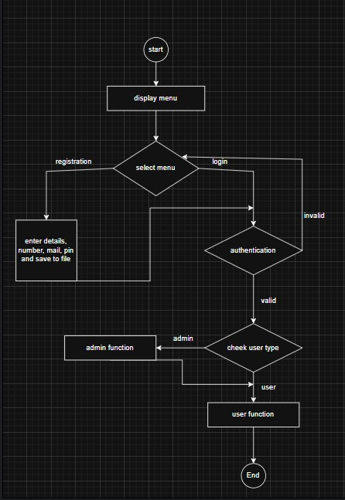
Class Diagram
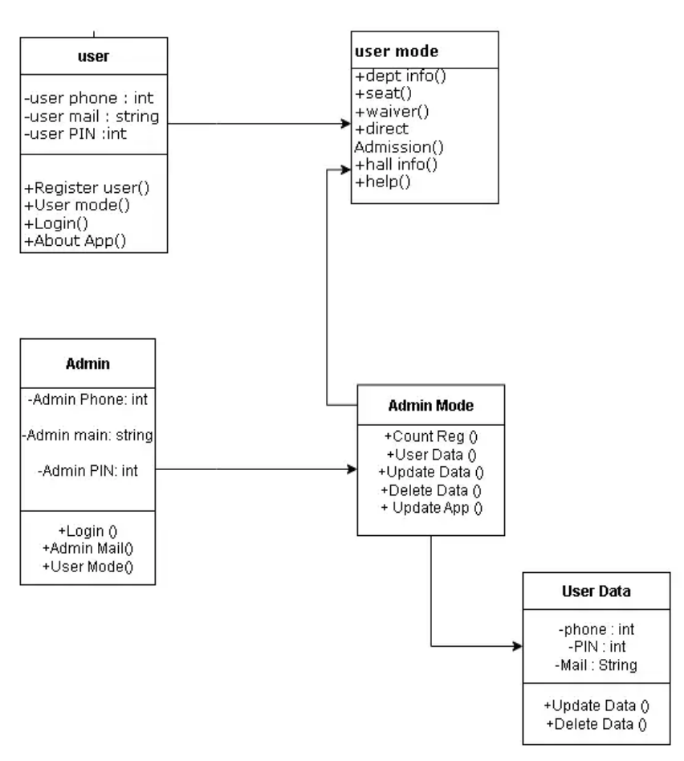

Programming Language & Features Used

Language:

C Programming Language

- Used to develop DIU Info Corner registration, login, and information system.

Conditional Statements:

- if, else if, else
Checking login credentials, validating GPA for direct admission, verifying menu choices.

- switch / case
Handling main menu, admin panel menu, and user panel menu selections.

Loops:

- while loop
Repeating menus until the user chooses to exit; navigating halls, departments, and waiver options.

- for loop
Iterating through admin or user data when validating credentials or counting registered users.

Functions:

- Custom Functions

(login(), registerUser(), adminMode(), etc.)
Modular design; separate tasks for login, registration, admin panel, user panel, and information display.

- File Handling:

fopen(), fprintf(), fscanf(), fclose()
Storing and retrieving user registration data in users.txt file.

String Handling:

- strcmp(), strcpy()
Comparing input credentials with stored data, copying user information into structures.

Structures:

- struct User
Stores user details like phone number, email, and PIN.

Console I/O:

- printf(), scanf(), getch(), system("cls")
For input, output, pauses, and clearing the screen between menu screens.

Project Plan

The project will be implemented following a structured and time-bound plan as per university standards:
Phase 1 – Requirement Analysis (Week 1-2):
• Meet with stakeholders to gather functional and non-functional requirements.
• Document all requirements and create a Software Requirement Specification (SRS).
Phase 2 – System Design (Week 3-4):
• Create system architecture, database schema, and UI mockups.
• Review and finalize designs with the supervisor.
Phase 3 – Development (Week 5-10):
• Implement core features including Registration/Login, Department Info, and Waiver Info.
• Integrate backend (Firebase) with the mobile application.
• Perform unit testing after each feature completion.
Phase 4 – Testing & Quality Assurance (Week 11-12):
• Conduct integration testing and resolve issues.
• Carry out user acceptance testing with sample students and staff.
Phase 5 – Deployment & Training (Week 13):
• Deploy the final system to the production environment.
• Provide training sessions and user manuals for admins and end-users.
Resources: Development team, Testing tools, Firebase backend.

Budget

The estimated project budget (in Bangladeshi Taka BDT) is presented below:
------------------------------------------------------------
Item Estimated Cost (BDT)
------------------------------------------------------------
Development Tools (Open-source) Free
Cloud Hosting ( 1 months) 2,000
Domain Registration ( 4 months) 750
Testing Devices (shared use) 3,000
Miscellaneous 5,000
------------------------------------------------------------
Total Estimated Cost: 10,750
Funding Source: This project will be funded through Daffodil International University's departmental project budget allocation and potential additional support from institutional ICT funds.

Evaluation

Criteria:
- Functionality: Meets all listed features
- Usability: Easy navigation and mobile-friendly

Methods:
- User testing with sample students
- Feedback collection and iteration

Conclusion
The DIU Info Corner app centralizes all important student information, improving accessibility and reducing confusion for new and existing students. Future improvements may include chatbot integration and multilingual support.

User Manual

1. Start: This is the main menu of DIU Info Corner System. It provides options to register as a user or admin, log in as an admin, faculty, or student, and get info about this app or exit the system. Users select a choice by entering the corresponding number.

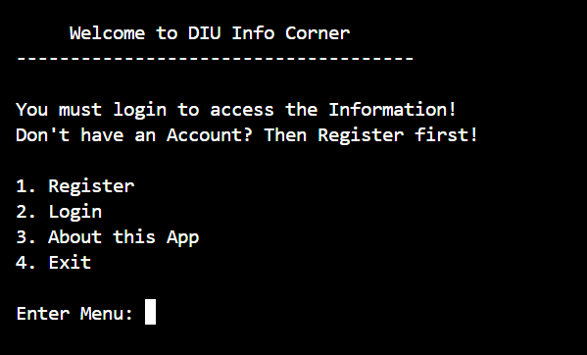

2. User registration: This option allows a new user to register by providing phone number, email and 4-digit pin. Upon successful registration, a confirmation message ("regestration successfully! Now login please") is displayed.
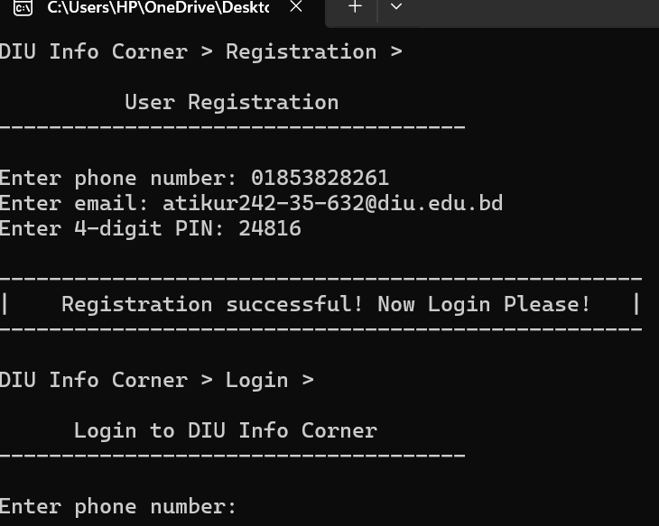

3.Login: user login by providing phone number and 4-digit pin. if number and pin matched, it would be showed login successful. Then press any key to clear and continue.
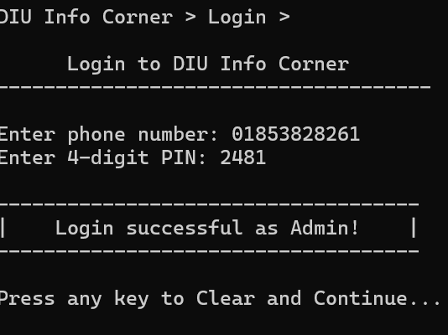

4. Admin mood: If login as an admin it will shoes the admin mood. And here some option like user panel, admin panel, and logout. You can choose any option.
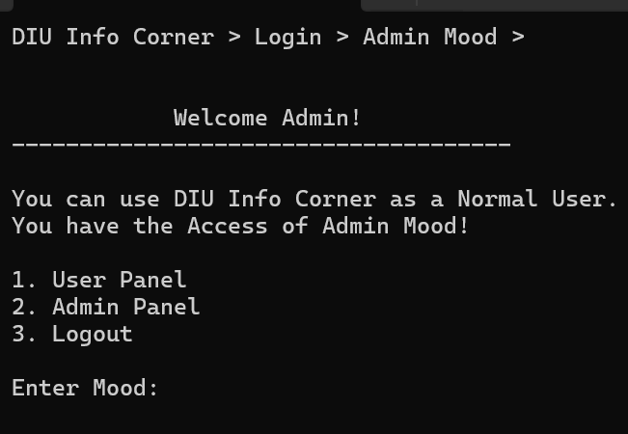

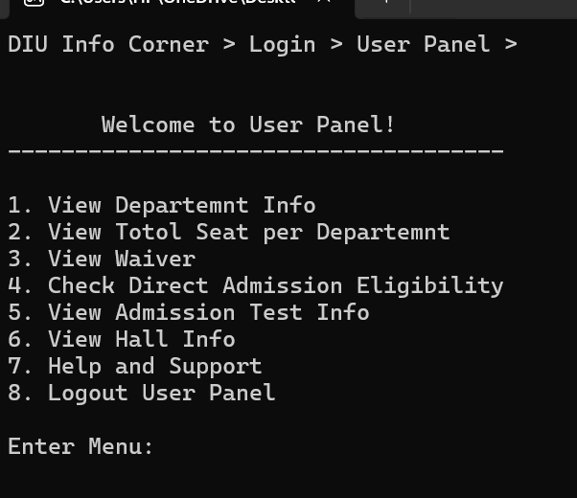
5. User panel: if you press 1 it will go to the user panel and display 1-8 option and you can choose any one for more details.

6. Department information: if you enter 1 in user panel it will go to the department information site. And here is the total 15 department name. you can choice anyone for get information of this department. Or press 16 it will go back to the user panel.

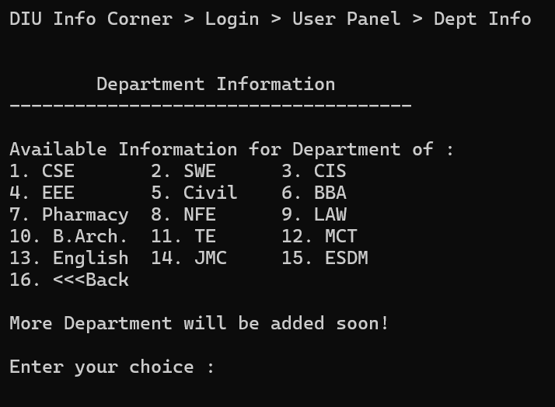

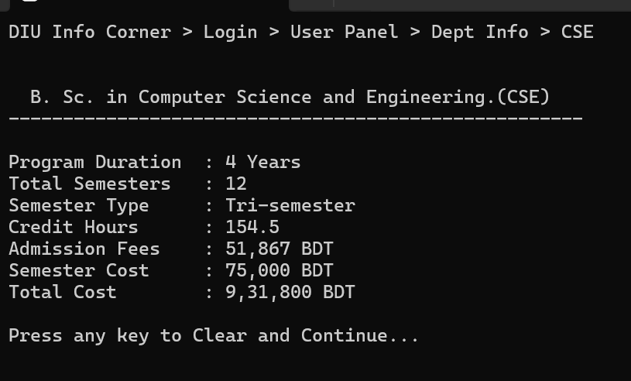

7. Total seat: in user panel if you press 2 it will show the total seat per department.
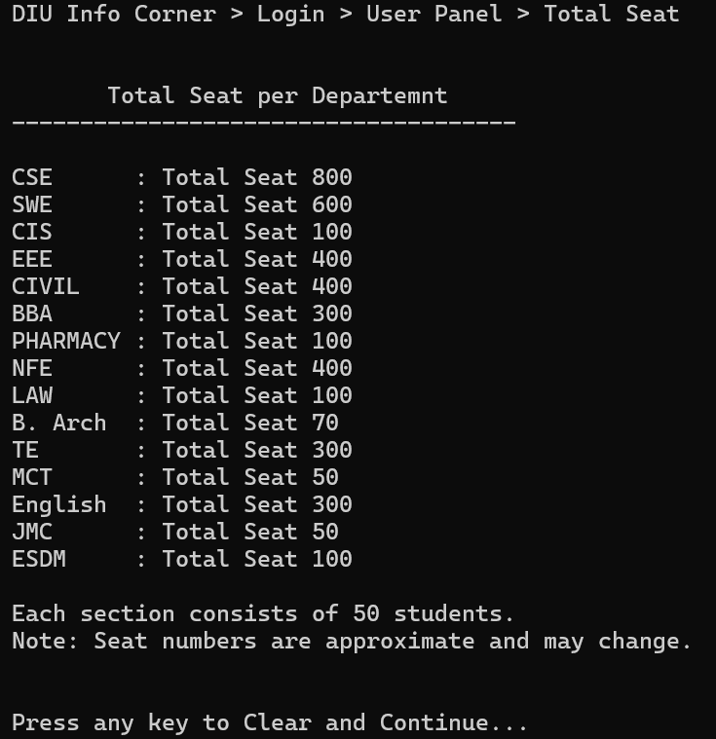

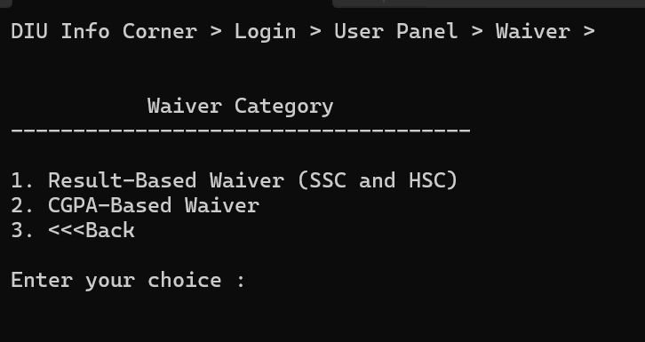
8. Waiver: In user panel enter 3, it will show the waiver category (result base and cgpa base).

If enter 1 it will go to the result-based waiver (SSC and HSC) interface.
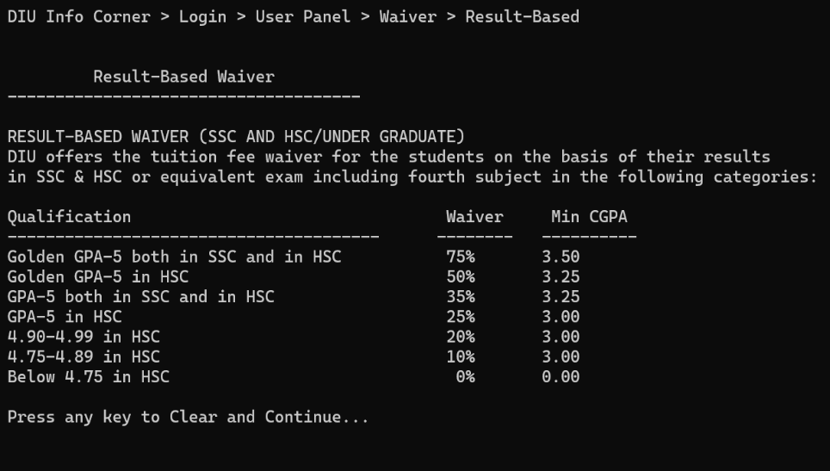

If enter 2 it will go to the cgpa based waiver interface.
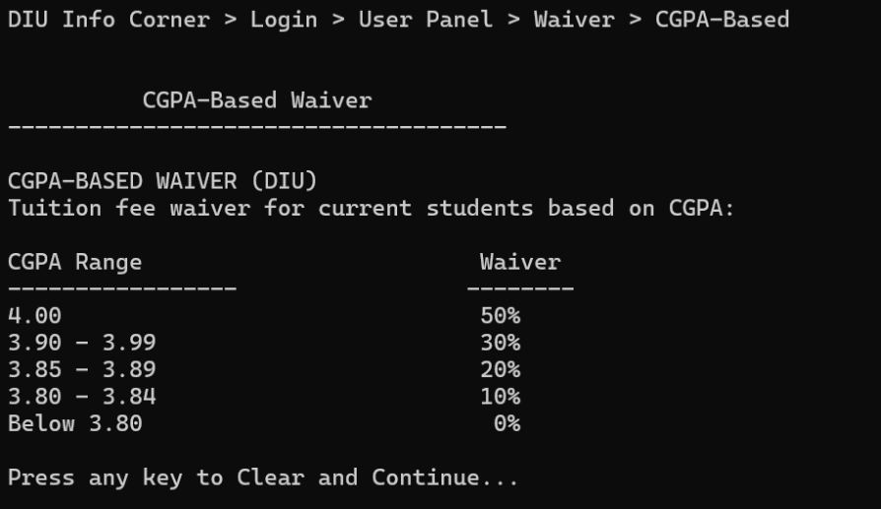

9. Direct admission: Enter 4 in user panel it will go to the interface which is shows that who are eligibile for direct admission. If a student meet 4.5+ gpa criteria in both ssc and hsc then it will eligible for direct admission other wise they are likely required to sit the diu admission test.
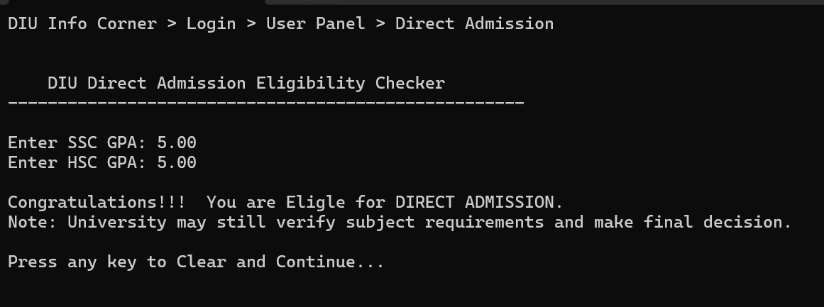

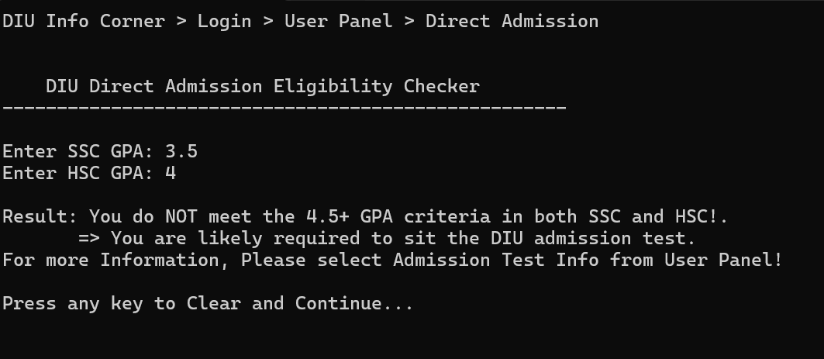

10. Admission test information: Enter 5 it will go to the “admission test information” interface. In this interface it shows some note and admission office phone numbers. Student can get information about the admission test by contacting those given number.
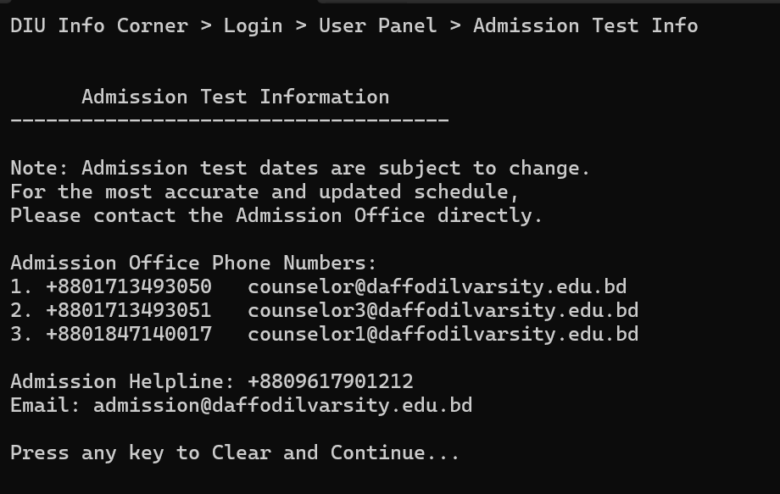

11. Hall info: Enter 6 it will show the interface of hall information. Here the two option which are given information about male and female hall.
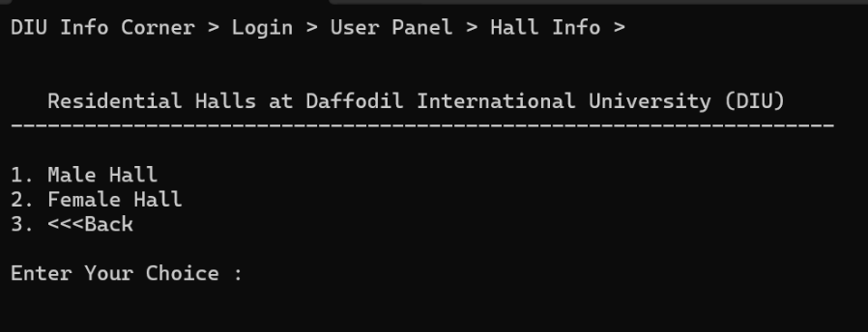

Enter 1 for male hall information.
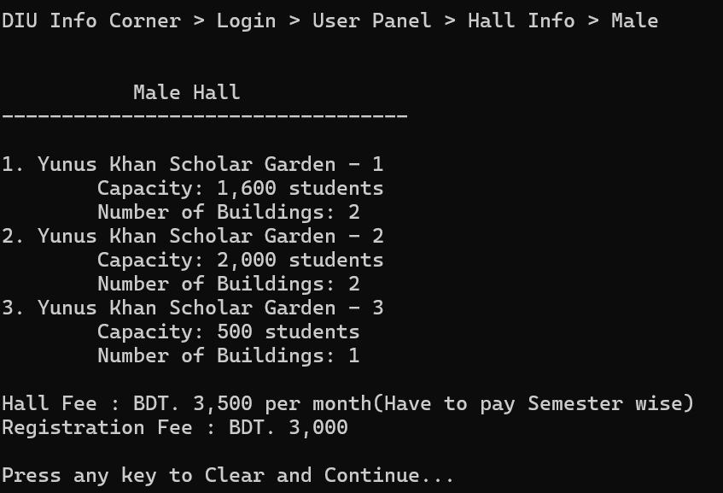

Enter 2 for female hall information.
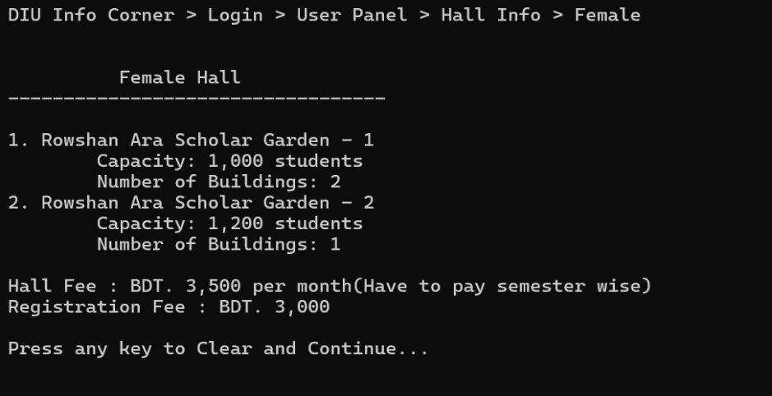

12. Help and support: enter 7 for help and support. Here the admin contact list given, the admin are always ready to help the user problem.
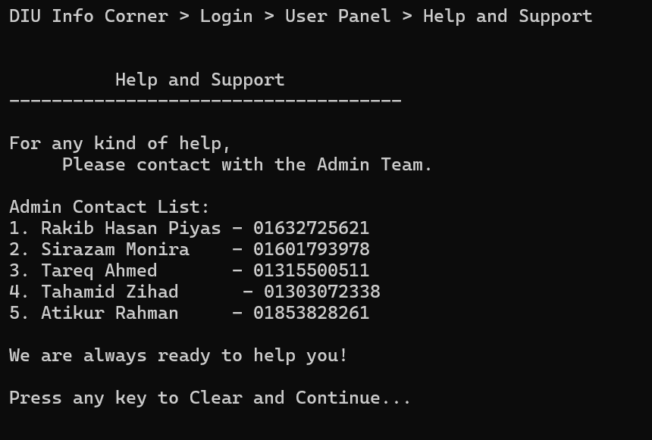

13. Admin mood: In login interface Enter 2 for admin panel. The admin panel interface shows that admin can control the app and they can 1. view total registered users, 2. view all user registration data, 3. update user data, 4. Delete user data, 5. Update app data and 6 for excite.
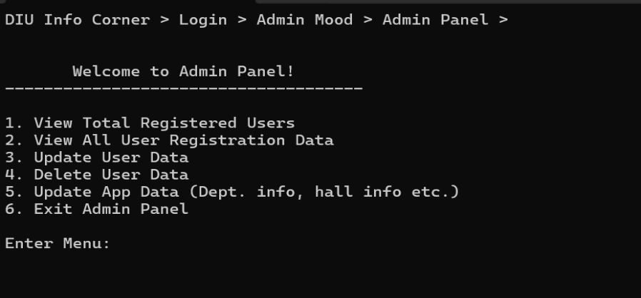

14. Registered user: Enter 1 for registered interface. admin can see the total registered users.
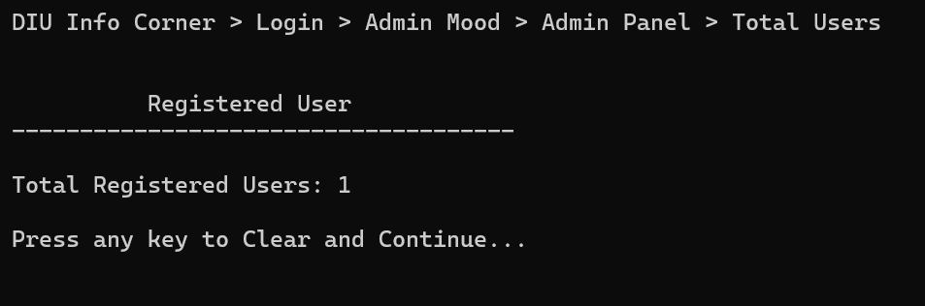

15. User data: Enter 2 for registration data. Admin can collect data from this interface which are registration into this app. The phone number, email and pin can collect admin.
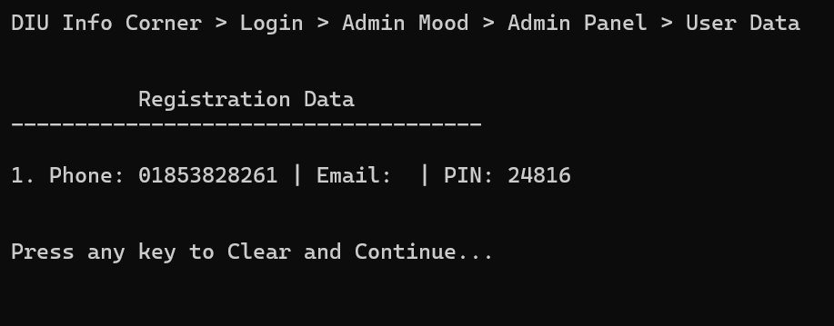

16. Update data: Enter 3 for update data. Here admin can update user data.

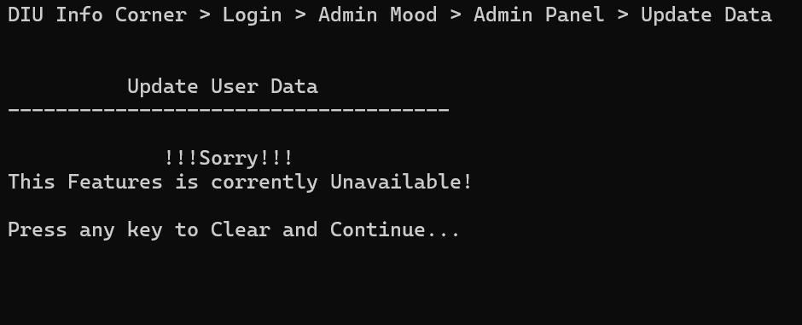

17. Delete data: Enter 4 for delete data. Admin can delete user data in this interface.
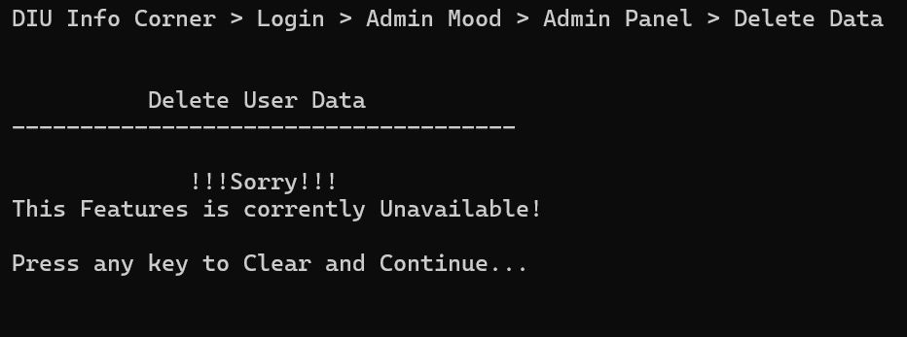

18. Update data: Enter 5 for update data. Admin can update user data from this interface.
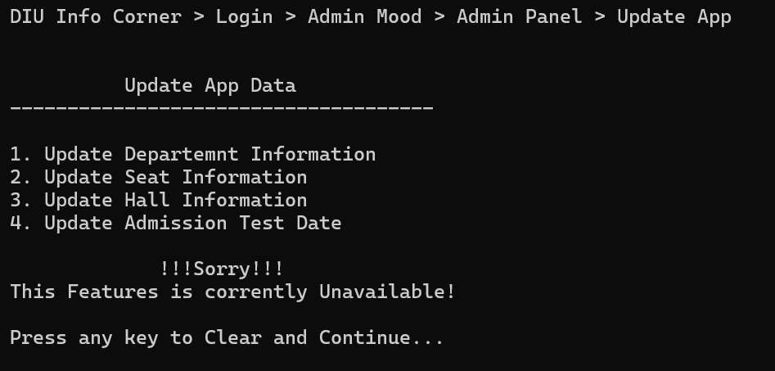

19. Logout: In admin mood interface enter 3 for logout. After enter 3, the confirmation message will show and then you have to press any key for clear and continue. Then you are successfully logout.
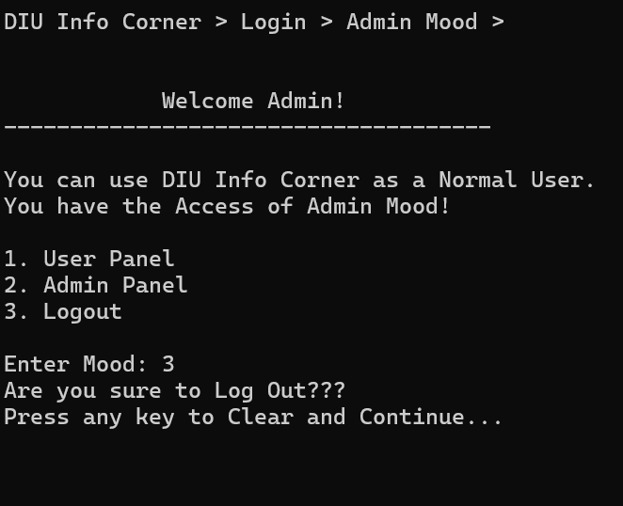

20. About this app: In diu info corner interface there is another option. In this interface if you enter 3 it will go to the interface of “about this app”. Entered the interface you can see the app name, app version, developer details, and app disclaimer.
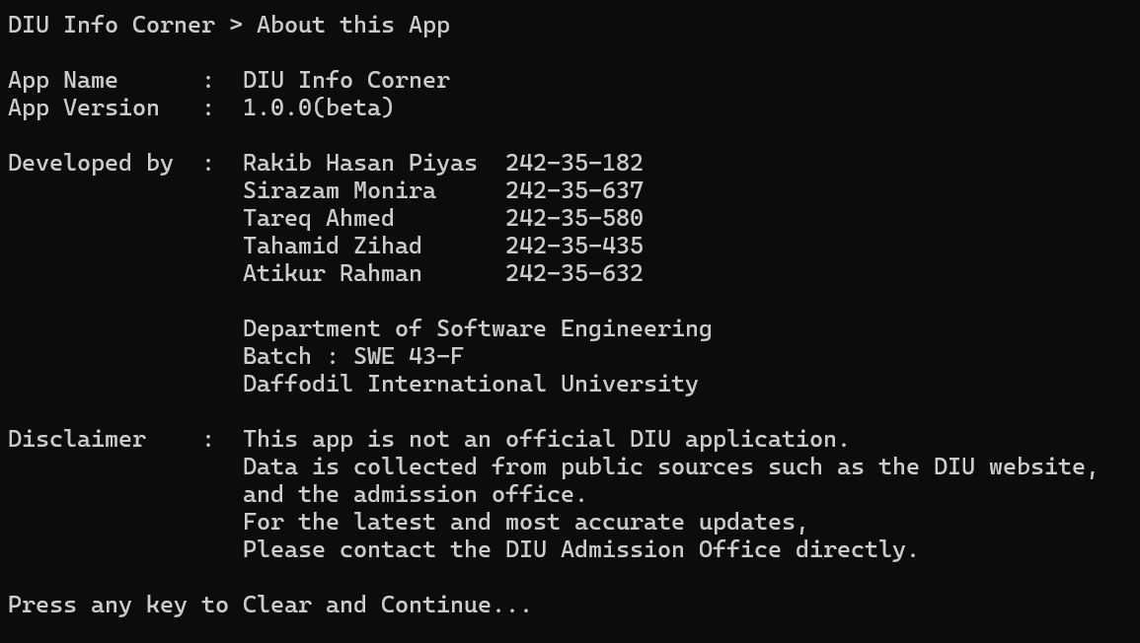

21. Exit: Come back to the main interface of this app if you want to exit then enter 4 and you will sequerly exit to the app.

